**Deployment of application on eks cluster using ecr and monitoring of it using Prometheus and grafana**

* **Create an ec2 instance**

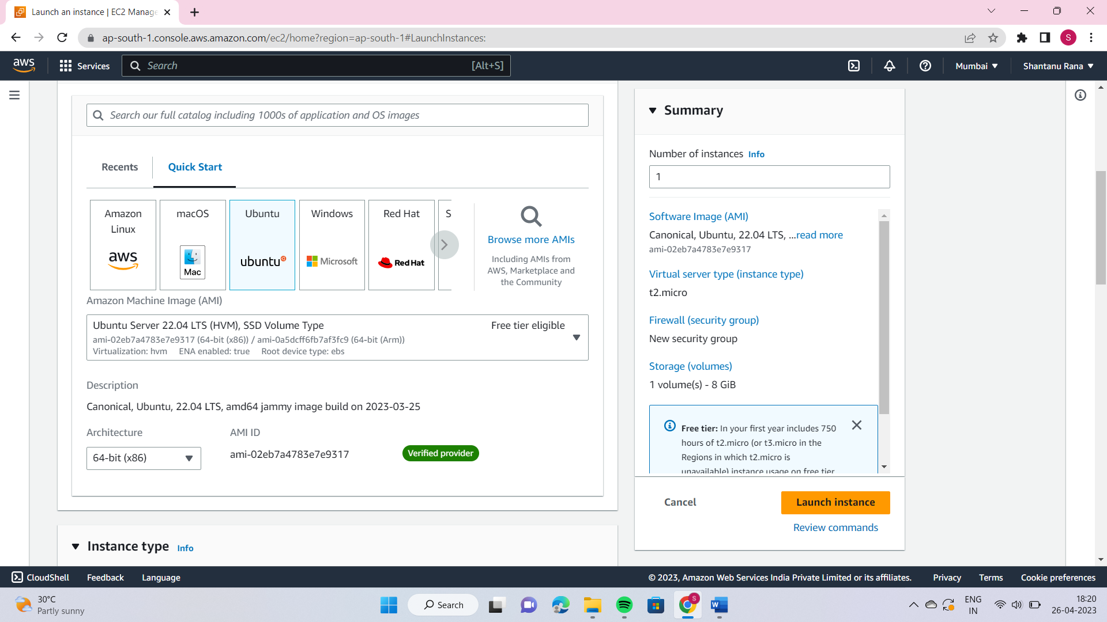

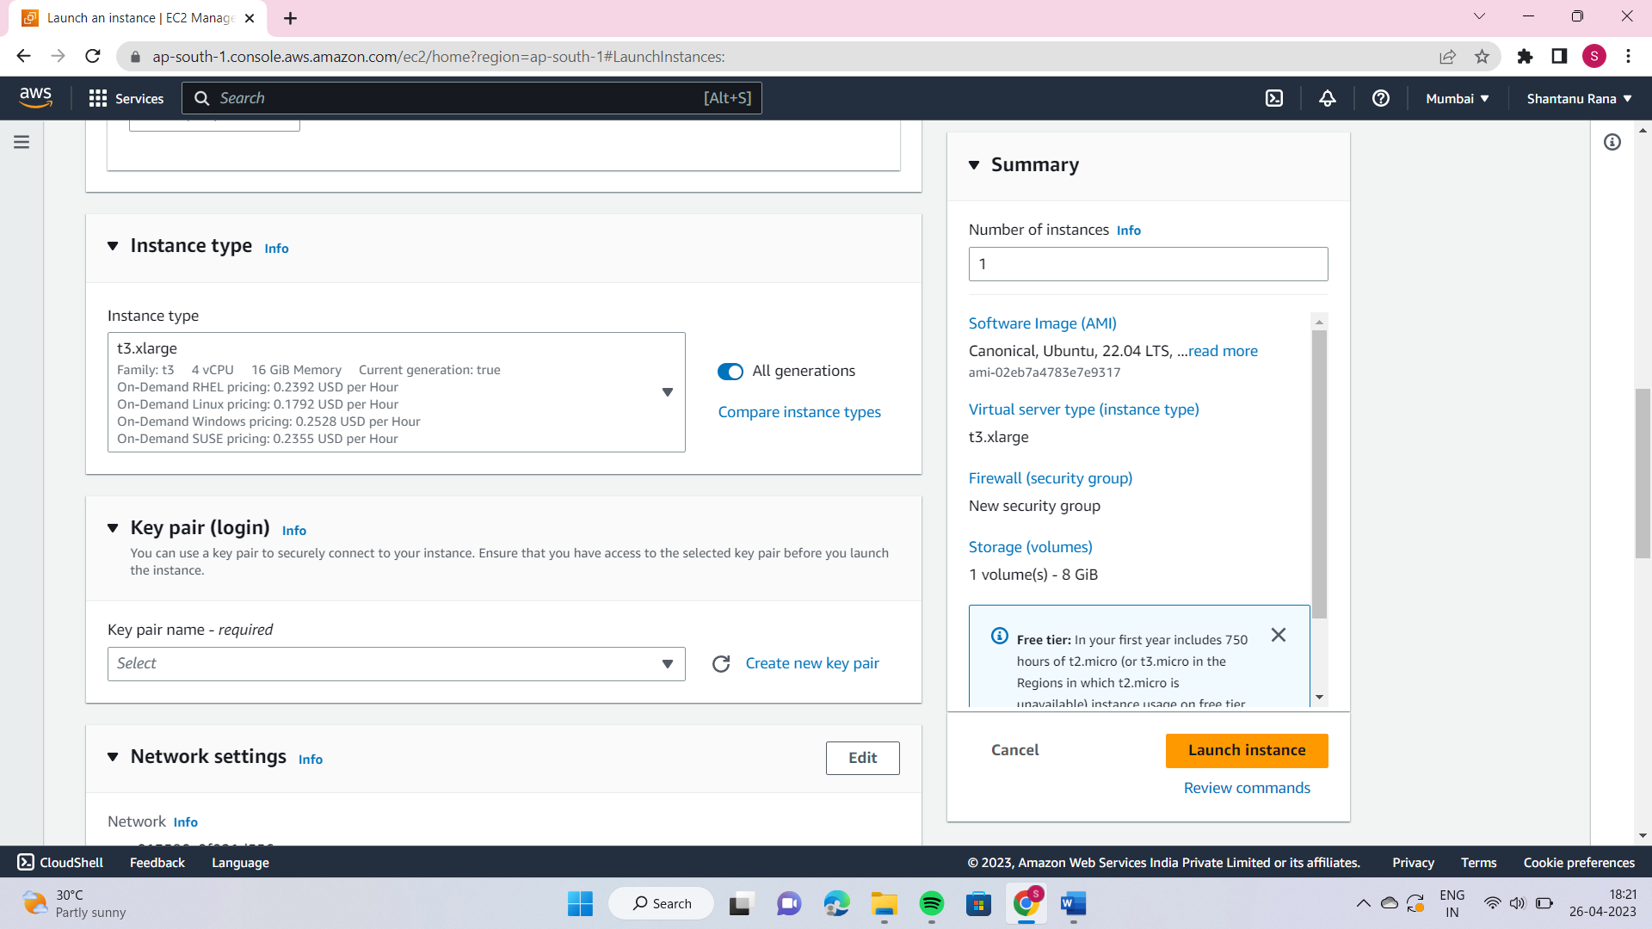

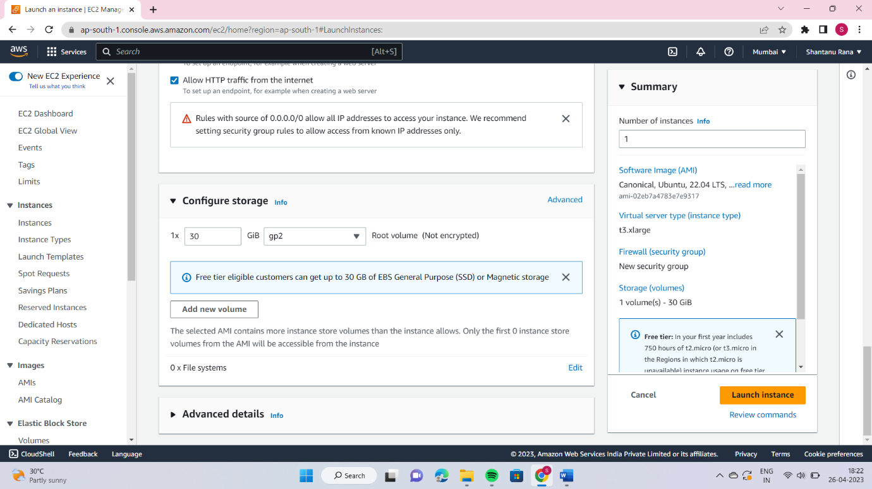

* **Install docker on ec2 instance by following commands**

sudo apt-get update  
 sudo apt-get install docker.io -y  
 sudo usermod -aG docker $USER && newgrp docker

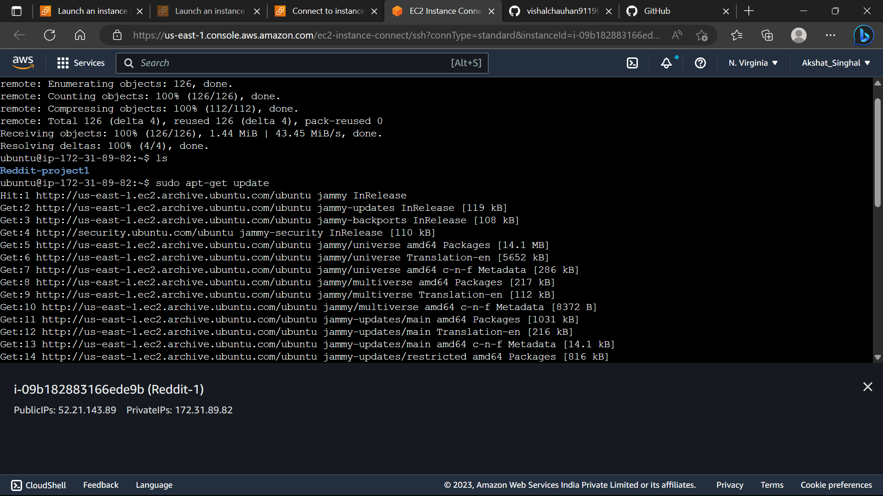

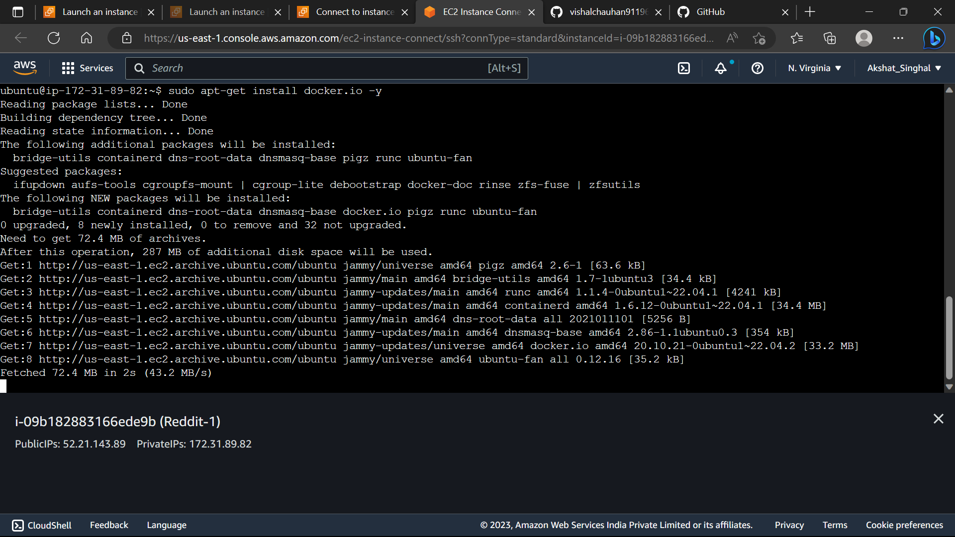

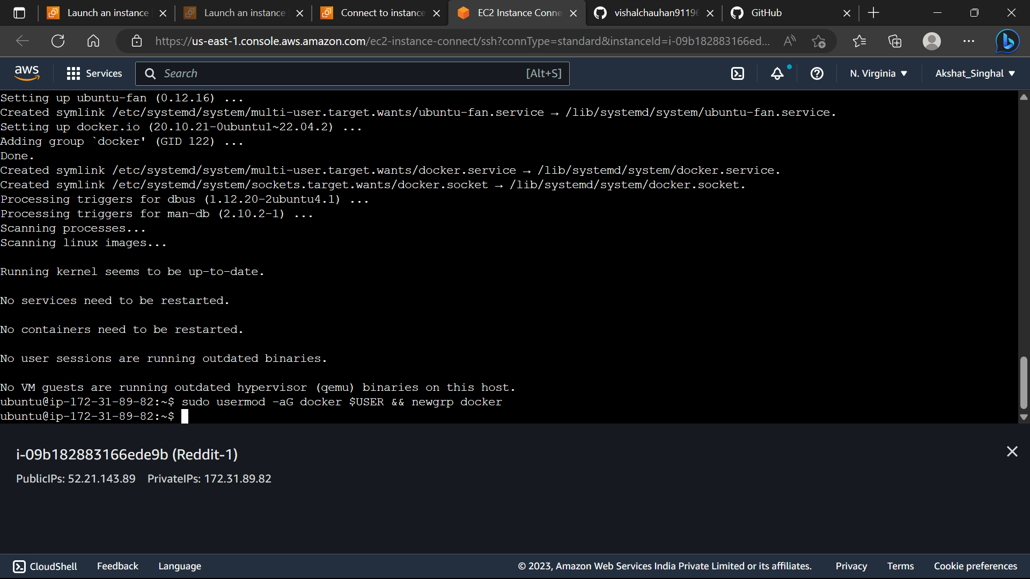

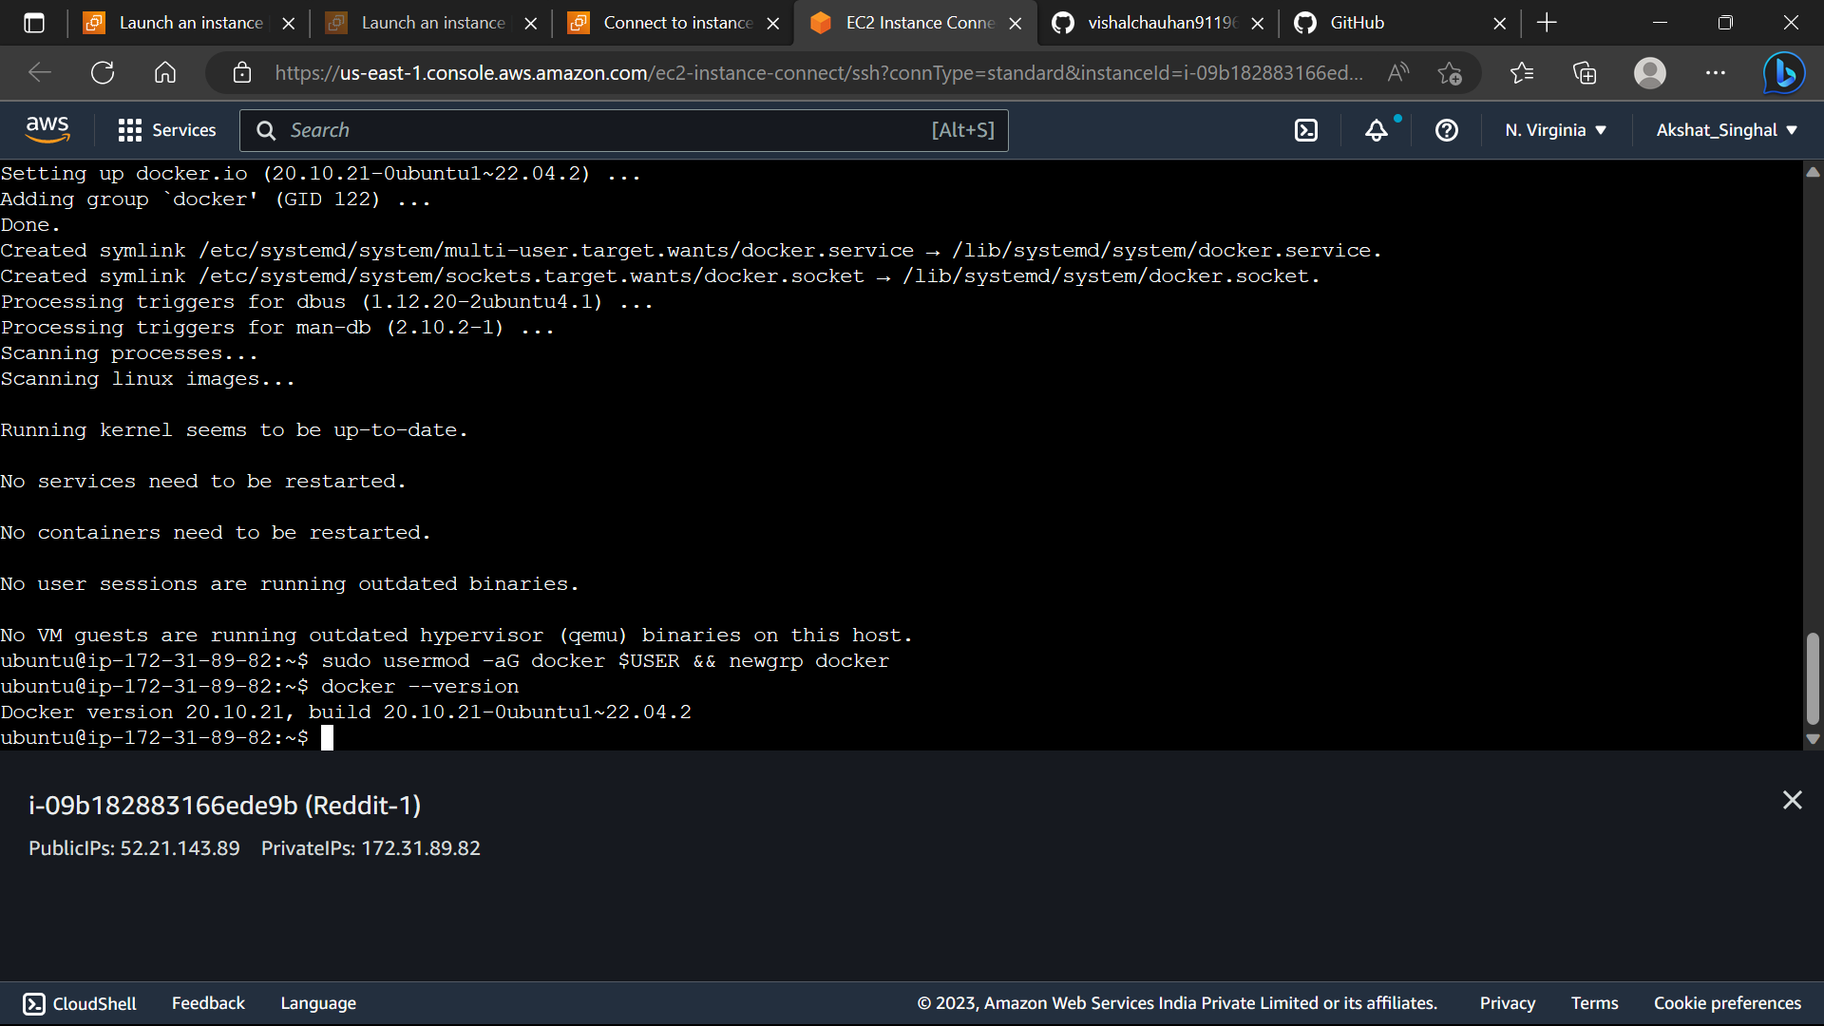

* **Clone the application in your EC2 Instance**

git clone https://github.com/vishalchauhan91196/Reddit-project1

cd Reddit-project1

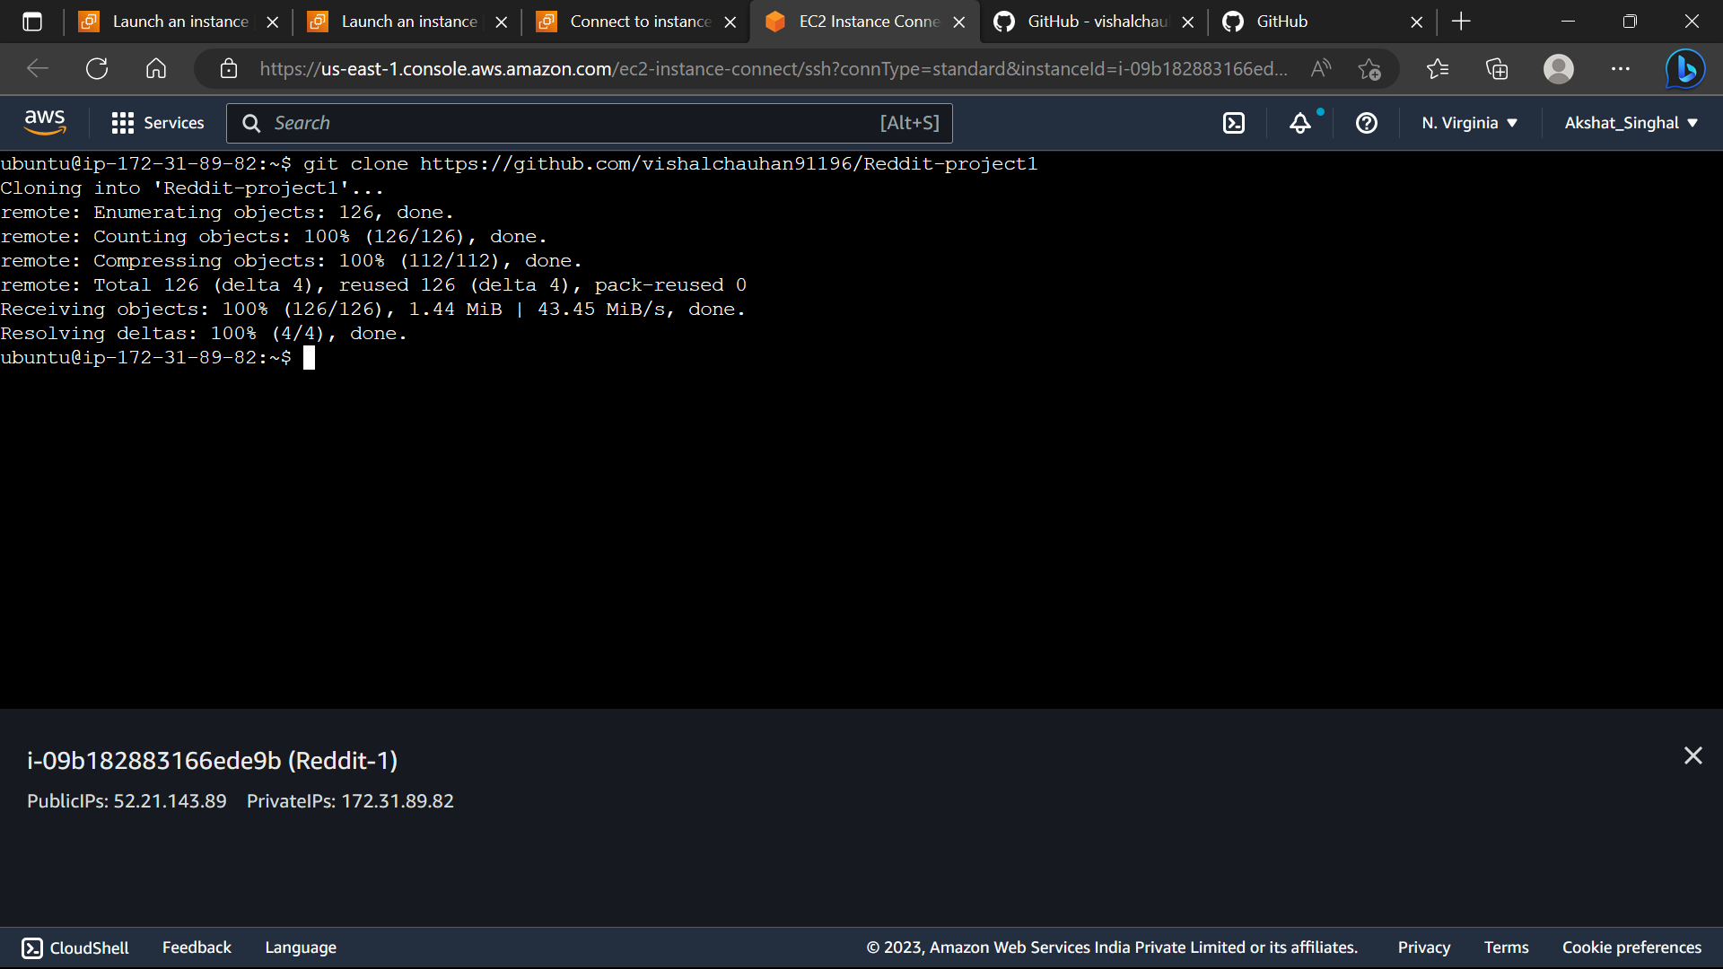

* **To install awscli follow type these commands**

curl "<https://awscli.amazonaws.com/awscli-exe-linux-x86_64.zip>" -o "awscliv2.zip"  
unzip awscliv2.zip  
sudo ./aws/instal

* **Create an ECR Repository**
* **sudo apt-get install awscli**
* **Click on account name**
* **Create access key**

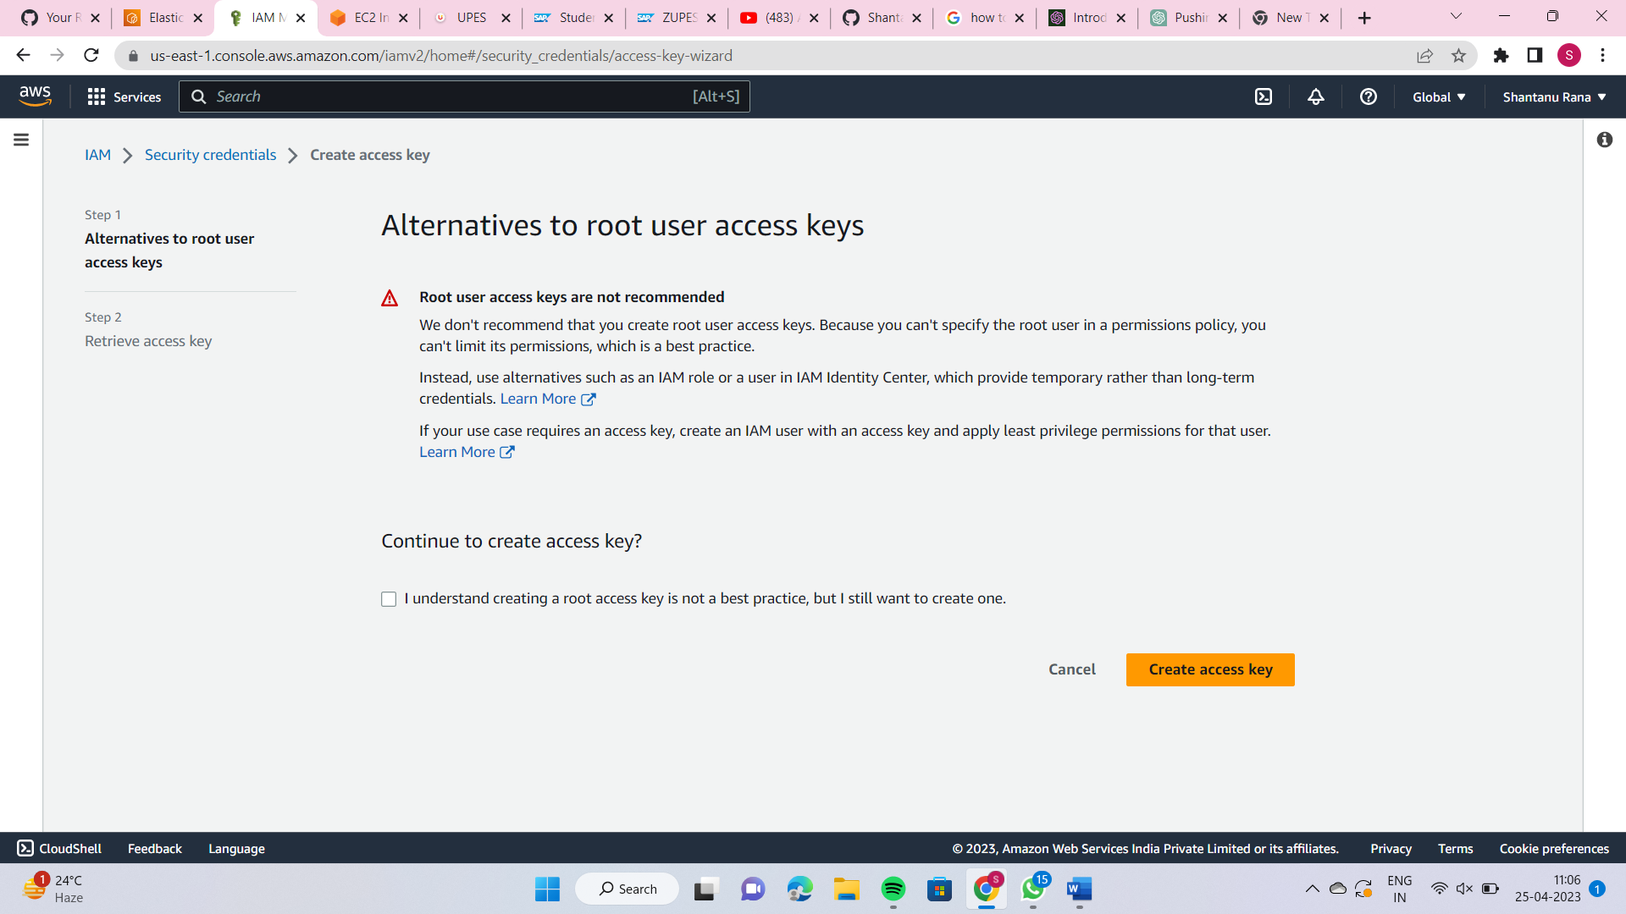

* **We can see the access key and Secret Access Key.**

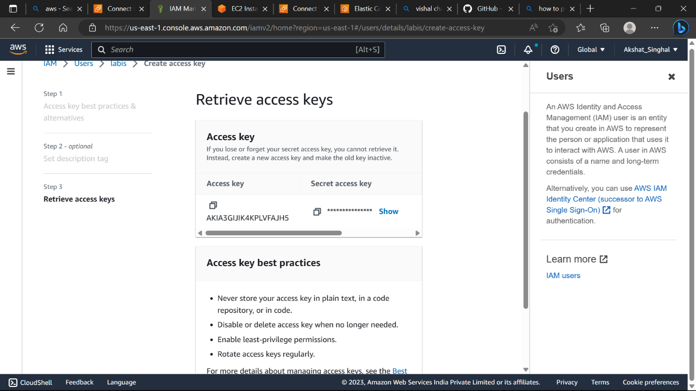

* **Type command aws configure and then provide the secret key and access key.**
* **Click on the ecr repository and view push commands**
* **Run all these commands in your EC2 instance**

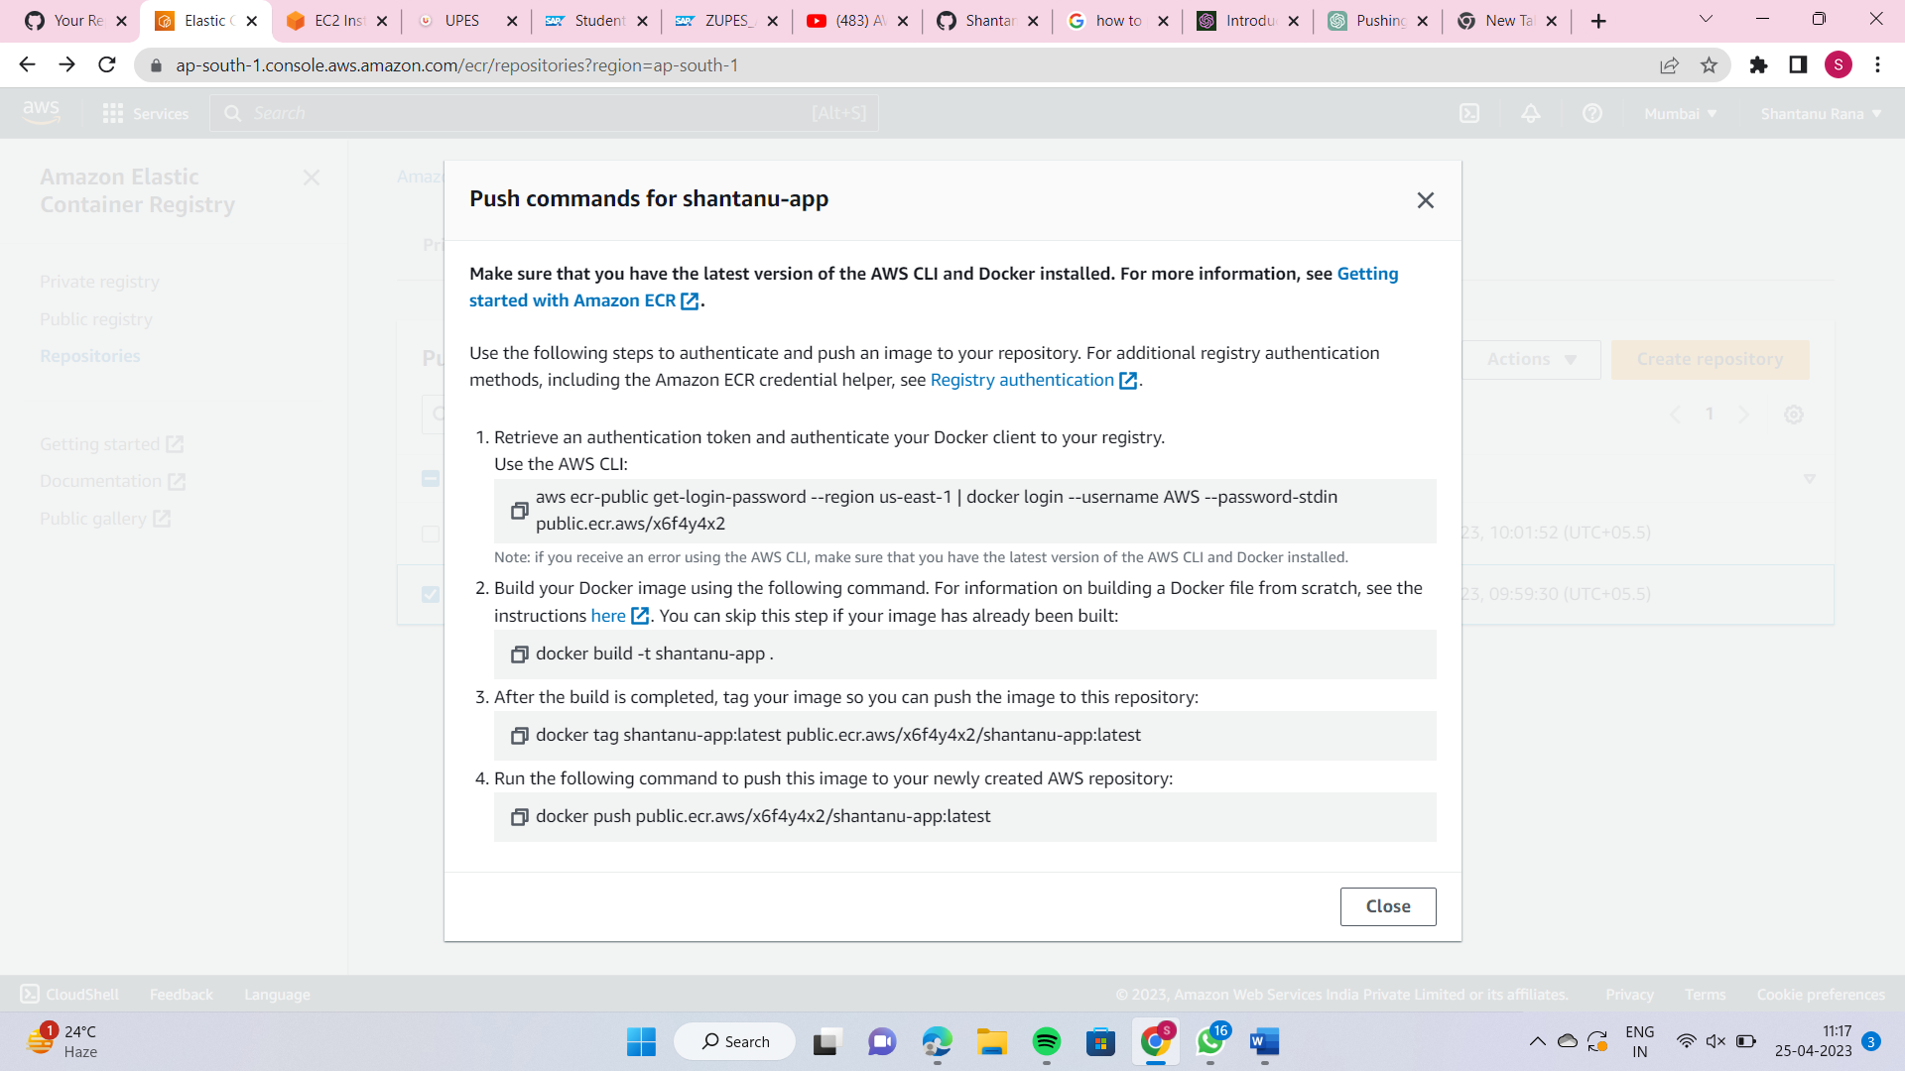

* **Then docker image will be pushed successfully.**
* **Search for CloudFormation**

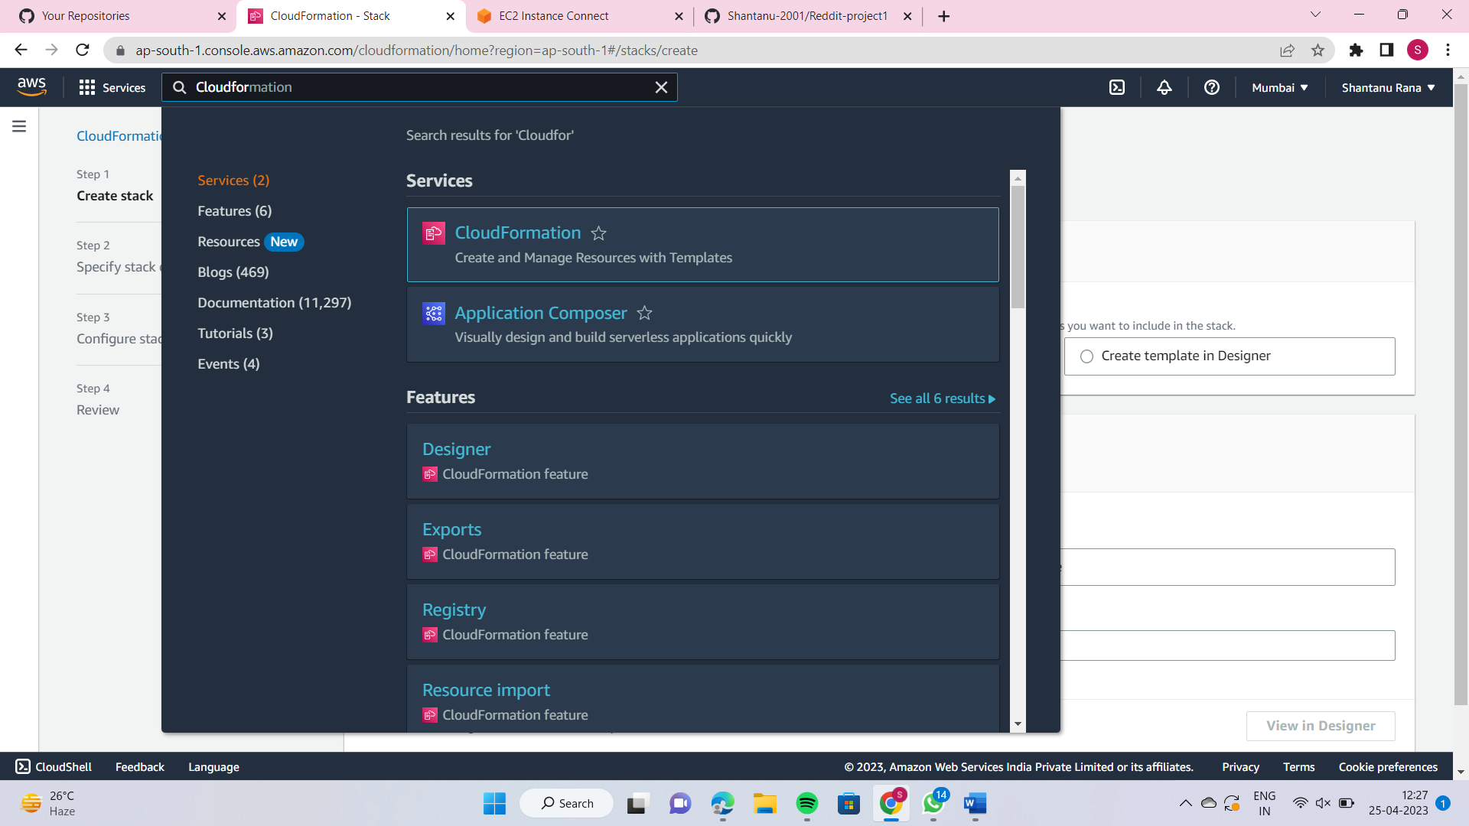

* **Click on create stack**
* **Paste the link for s3 url**
* **https://amazon-eks.s3.us-west-2.amazonaws.com/cloudformation/2020-06-10/amazon-eks-vpc-private-subnets.yaml**

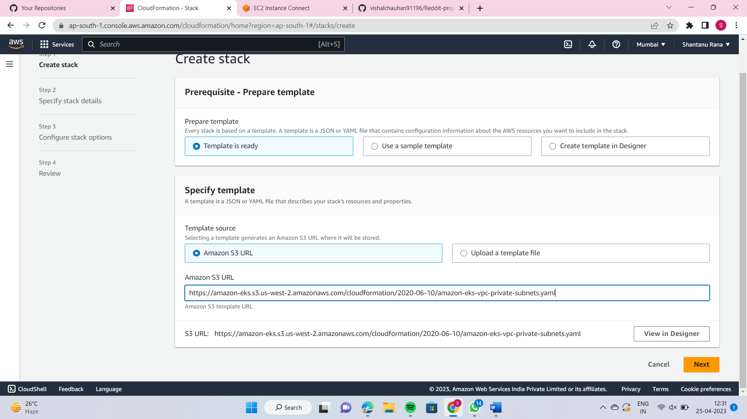

* **Enter the Stack Name**

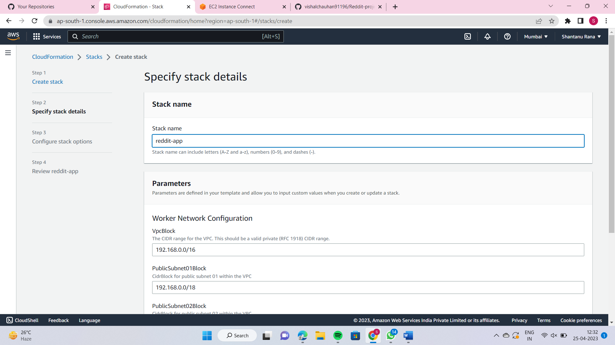

* **Click Next and then click on Submit**
* **Type VPC and and then check your VPC.**

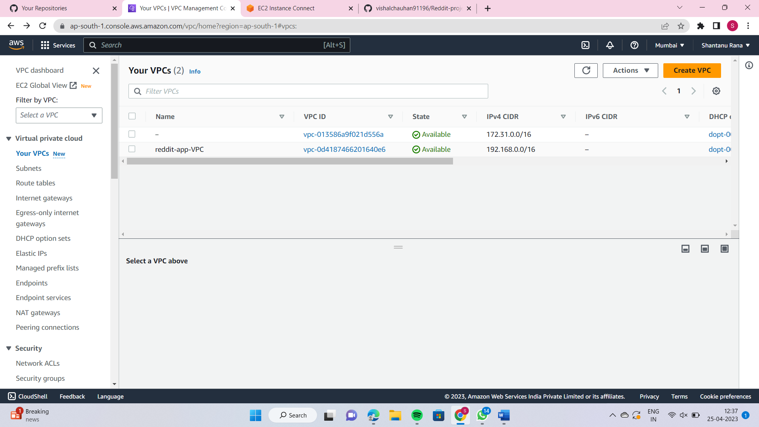

## For eksctl run these commands on instance

ARCH=amd64 PLATFORM=$(uname -s)_$ARCH

curl -sLO "<https://github.com/weaveworks/eksctl/releases/latest/download/eksctl_$PLATFORM.tar.gz>"

tar -xzf eksctl_$PLATFORM.tar.gz -C /tmp && rm eksctl_$PLATFORM.tar.gz

sudo mv /tmp/eksctl /usr/local/bin

## For kubectl run these commands on instance

curl -LO "<https://dl.k8s.io/release/$(curl> -L -s <https://dl.k8s.io/release/stable.txt)/bin/linux/amd64/kubectl>"

sudo install -o root -g root -m 0755 kubectl /usr/local/bin/kubectl

kubectl version --client

## For aws-iam-authenticator run these command on instance

curl -Lo aws-iam-authenticator <https://github.com/kubernetes-sigs/aws-iam-authenticator/releases/download/v0.5.9/aws-iam-authenticator_0.5.9_linux_amd64>

chmod +x ./aws-iam-authenticator

mkdir -p $HOME/bin && cp ./aws-iam-authenticator $HOME/bin/aws-iam-authenticator && export PATH=$PATH:$HOME/bin

echo 'export PATH=$PATH:$HOME/bin' >> ~/.bashrc

aws-iam-authenticator help

* **Create a cluster.yaml file where we are going to mention configurations of cluster such as vpc details and node group details.**
* **Cd Reddit-project1**

**ubuntu@ip-172-31-30-165:~/Reddit-project1$ vi cluster.yaml**

**apiVersion: eksctl.io/v1alpha5**

**kind: ClusterConfig**

**metadata:**

**name: EKS-Demo-Cluster**

**region: ap-south-1**

**vpc:**

**id: vpc-0d4187466201640e6**

**cidr: "192.168.0.0/16"**

**subnets:**

**public:**

**ap-south-1a:**

**id: subnet-07b97d231d48741ff**

**ap-south-1b:**

**id: subnet-0c29bba5b9a1b937c**

**private:**

**ap-south-1a:**

**id: subnet-03b0fc6b104c3c476**

**ap-south-1b:**

**id: subnet-05f952d17d4776e98**

**nodeGroups:**

**- name: public-workers-node**

**instanceType: t3.medium**

**desiredCapacity: 2**

**- name: private-workers-node**

**instanceType: t3.medium**

**desiredCapacity: 1**

**privateNetworking: true**

* **Create an ekscluster**

eksctl create cluster -f cluster.yaml --kubeconfig=~/.kube/config

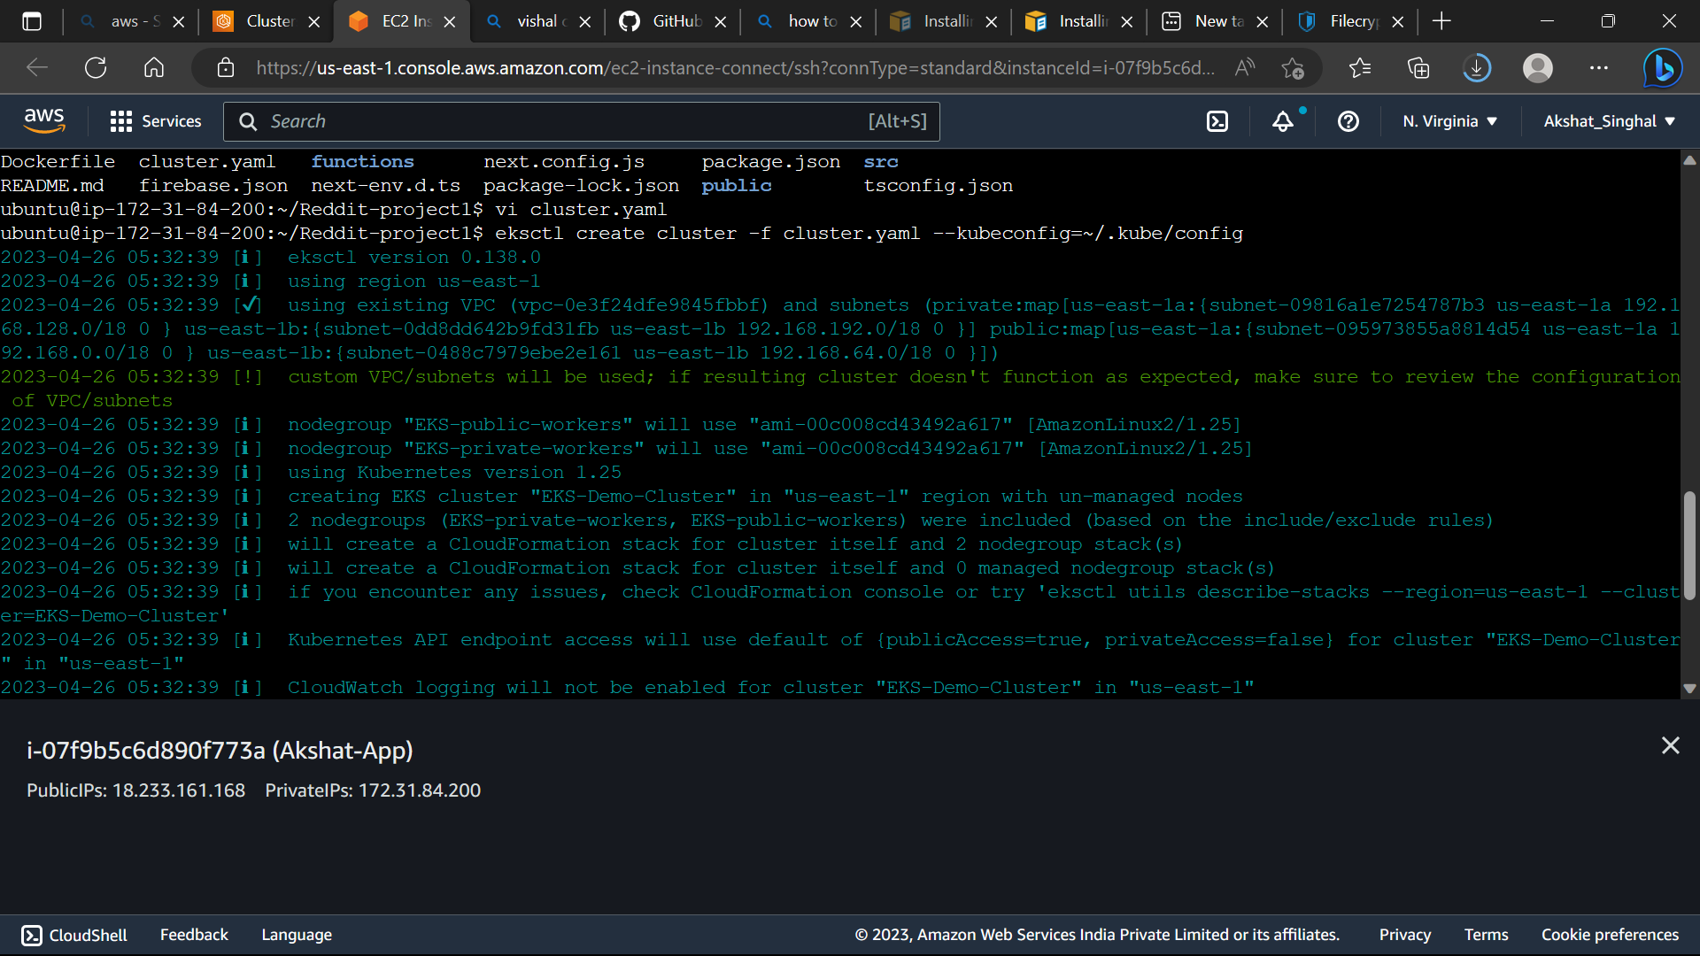

Cluster is created 🡪

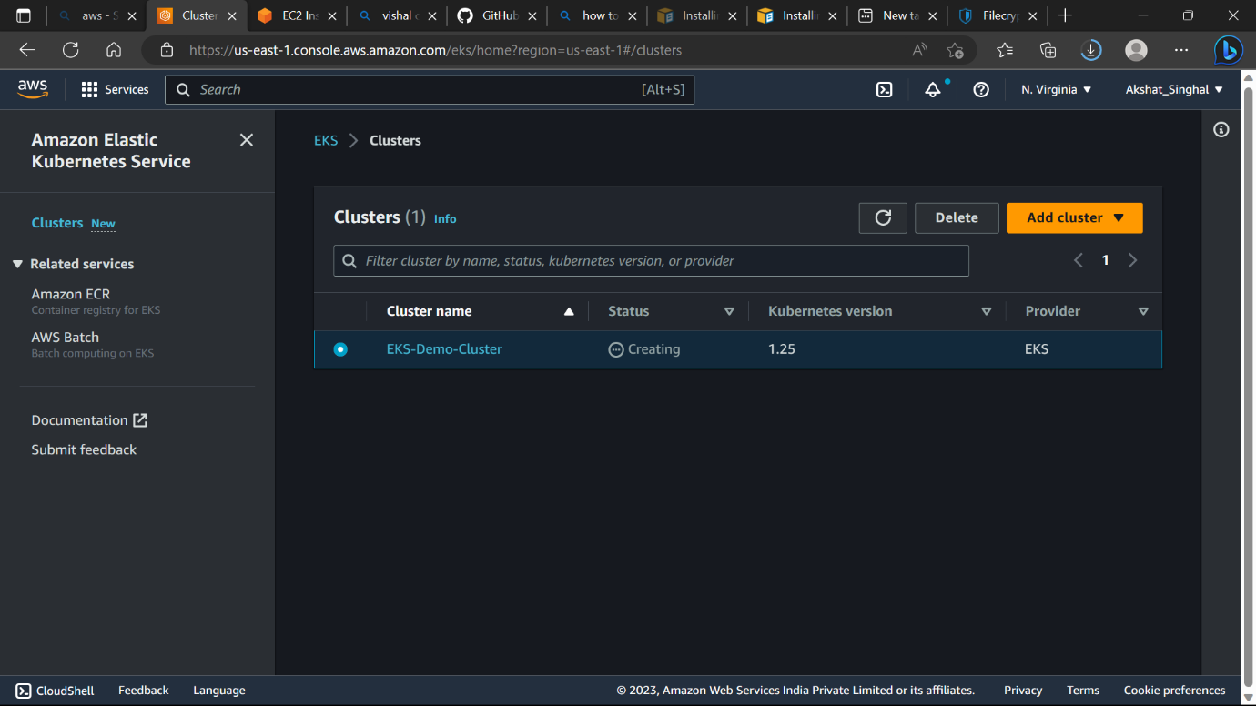

* aws eks --region ap-south-1 update-kubeconfig --name EKS-Cluster

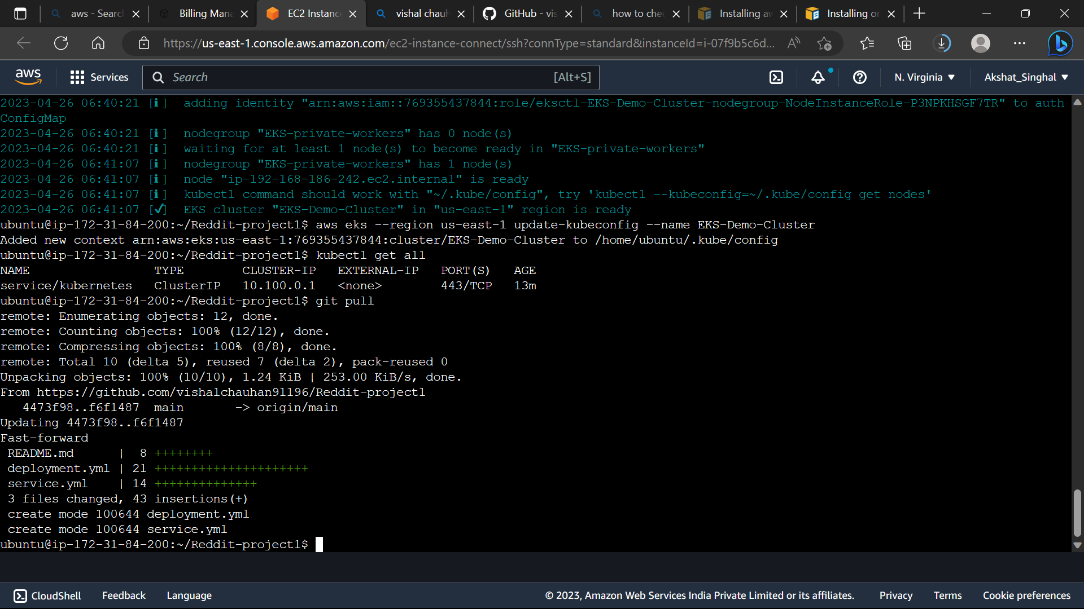

* **Vi deployment.yaml**

**apiVersion: apps/v1**

**kind: Deployment**

**metadata:**

**name: reddit-clone-deployment**

**labels:**

**app: reddit-clone**

**spec:**

**replicas: 2**

**selector:**

**matchLabels:**

**app: reddit-clone**

**template:**

**metadata:**

**labels:**

**app: reddit-clone**

**spec:**

**containers:**

**- name: reddit-clone**

**image: public.ecr.aws/x6f4y4x2/akshat-app:latest**

**ports:**

**- containerPort: 3000**

* **kubectl apply -f deployment.yaml**
* **vi service.yml**

**apiVersion: v1**

**kind: Service**

**metadata:**

**name: reddit-clone-service**

**labels:**

**app: reddit-clone**

**spec:**

**type: NodePort**

**selector:**

**app: reddit-clone**

**ports:**

**- nodePort: 31479**

**port: 8080**

**targetPort: 3000**

* **kubectl apply -f service.yml**
* **Kubectl get all**
* **kubectl get pods -o wide**
* **kubectl get nodes -o wide**

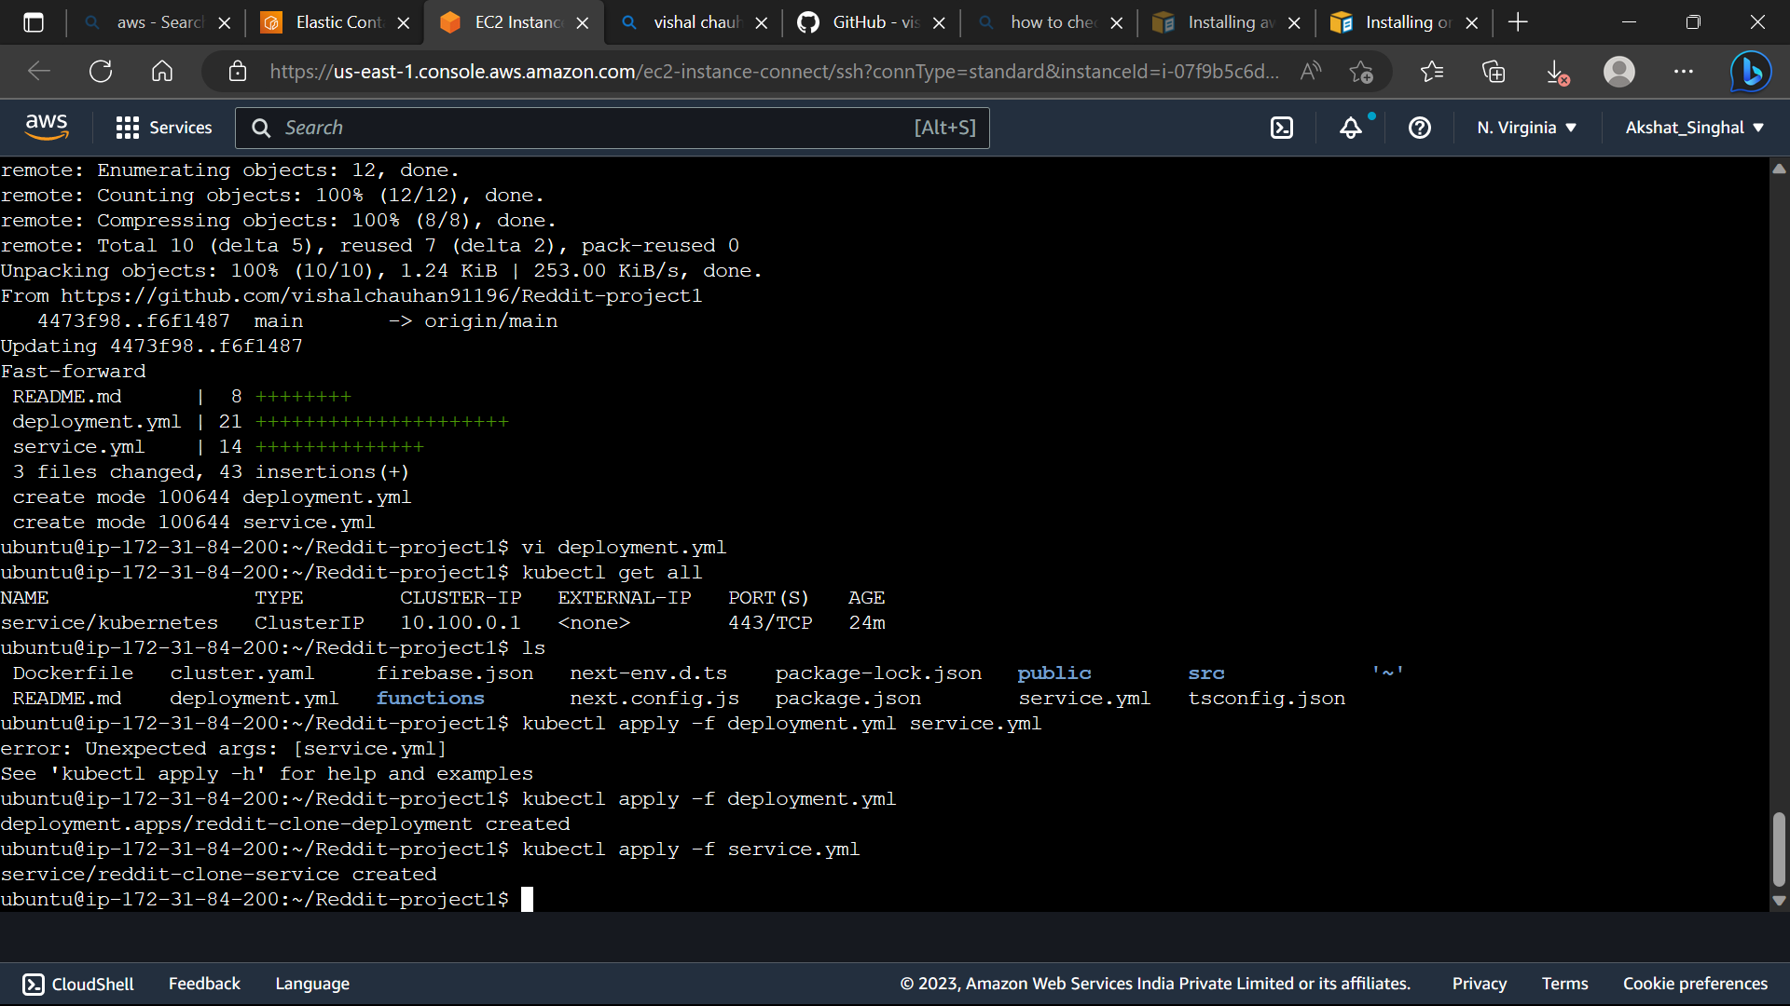

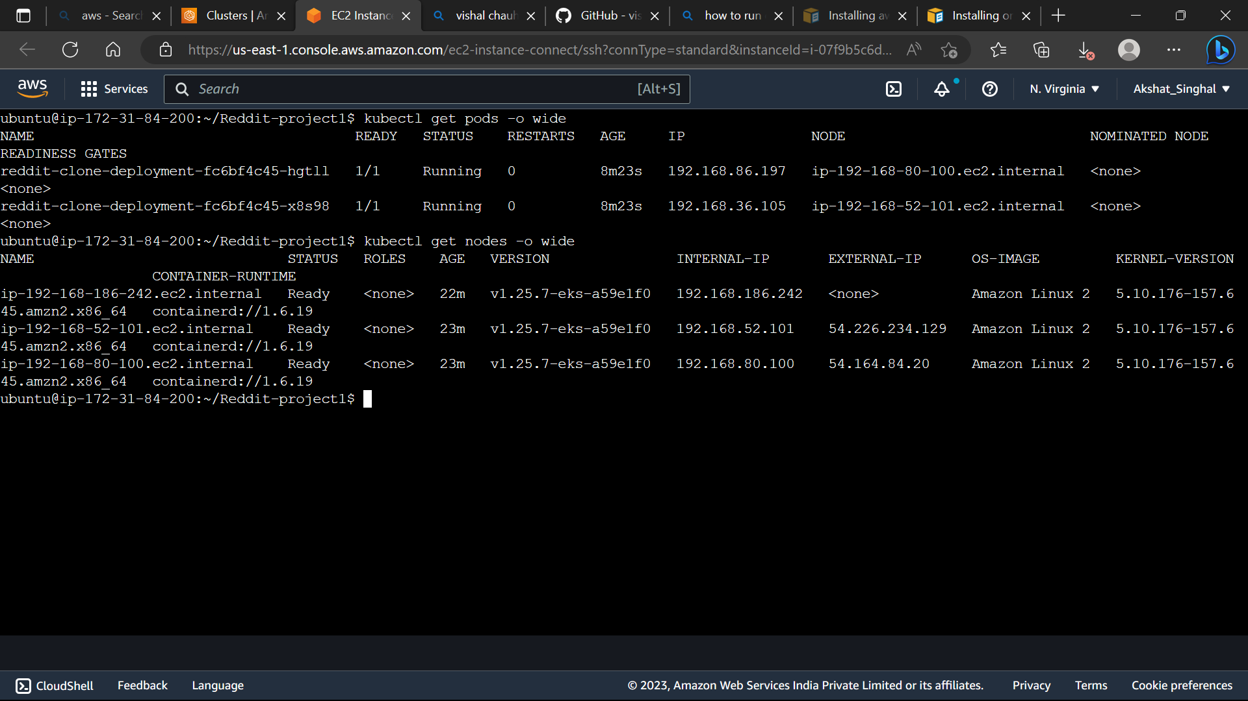

* **Go to the instances**

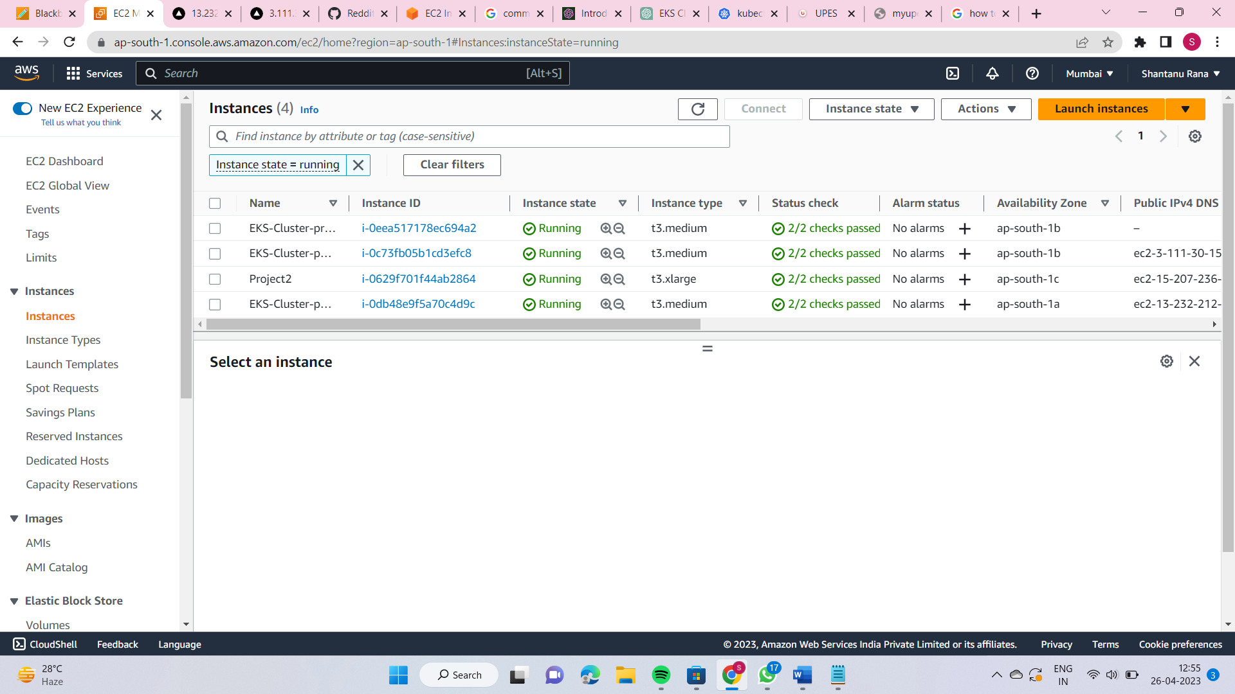

* **The public worker node is exposed to port number 31479 so we need to go to the security groups of each public worker node(Basicall the Instances where our containers are running) and edit inbound rules by adding 31479port to it and save.**

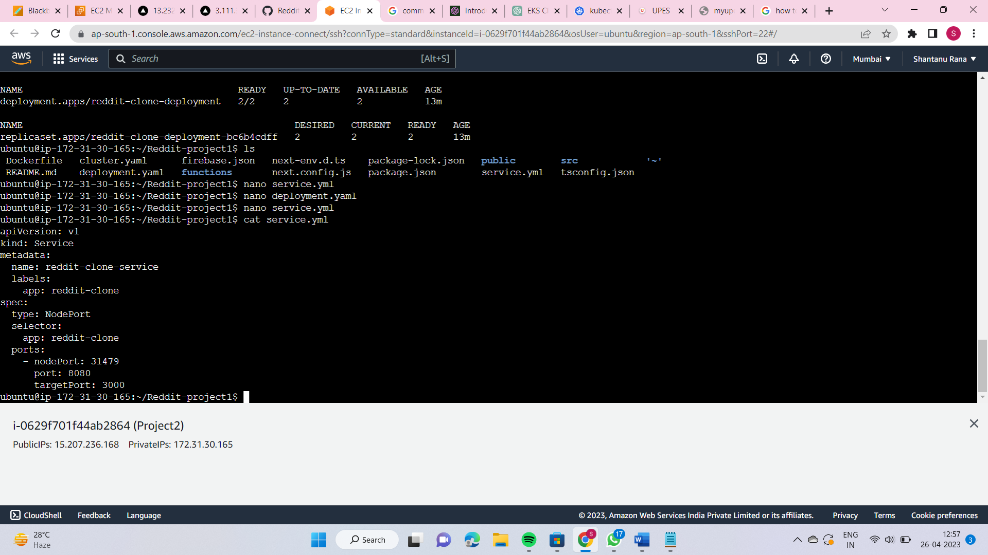

* **Go to the instances**

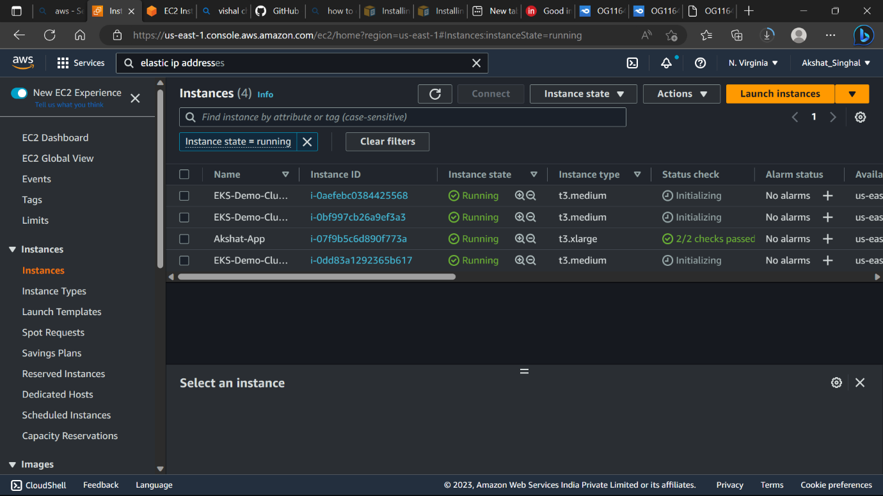

* **Click on instance, Check the security groups.**

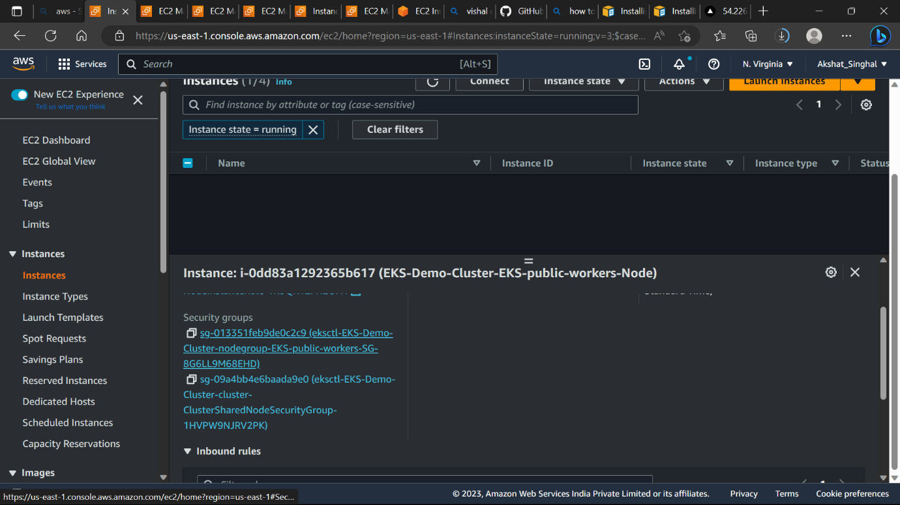

* **Select the security group and edit inbound rules**

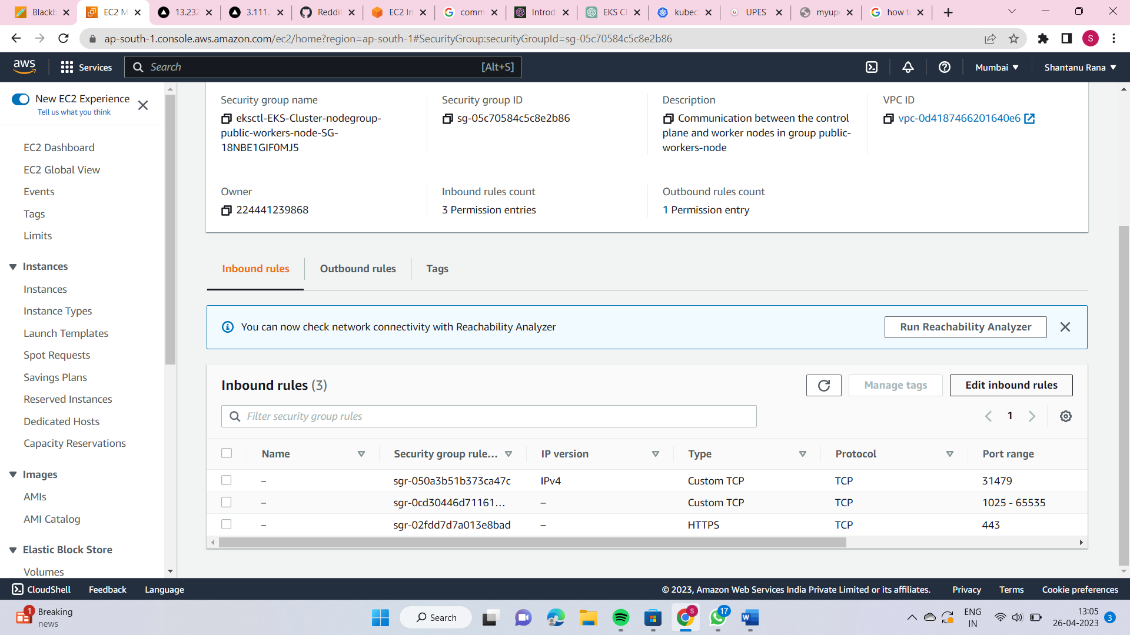

* **Create the new rule**

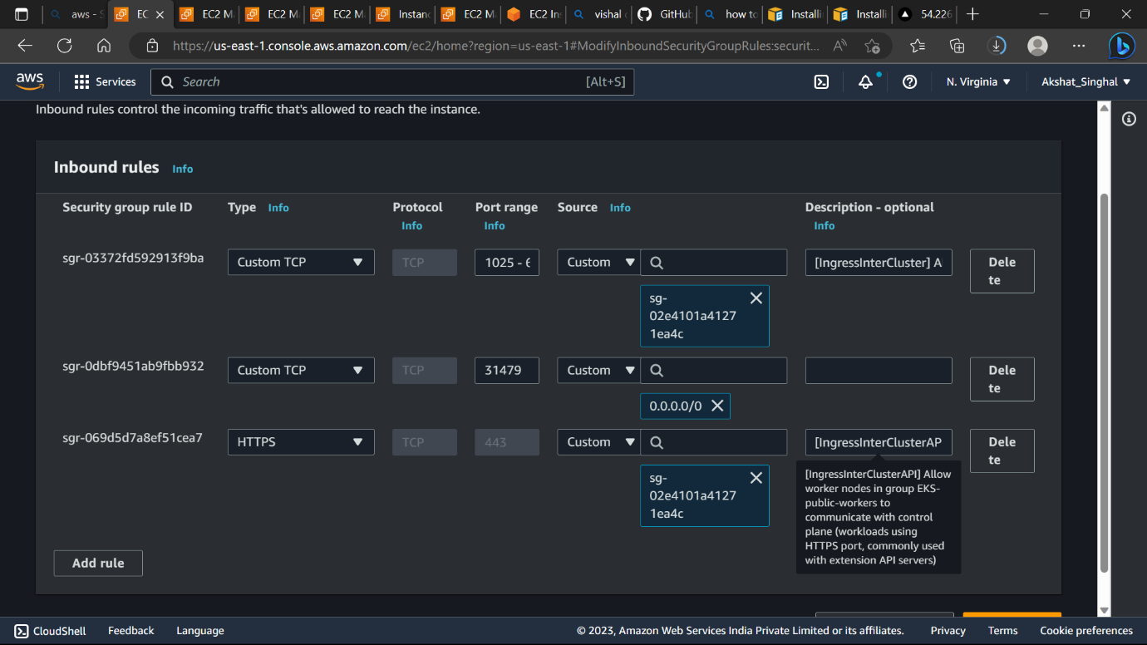

* **Save rules and go to networking and click on ip address.**

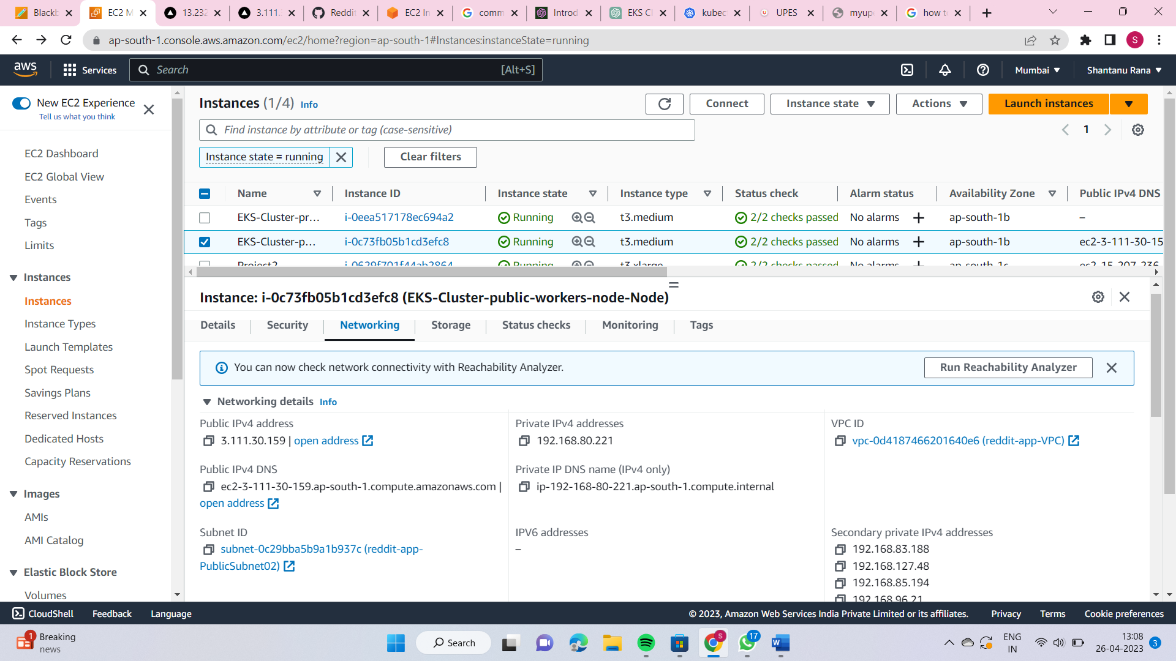



* [**http://54.226.234.129:31479**](http://54.226.234.129:31479)

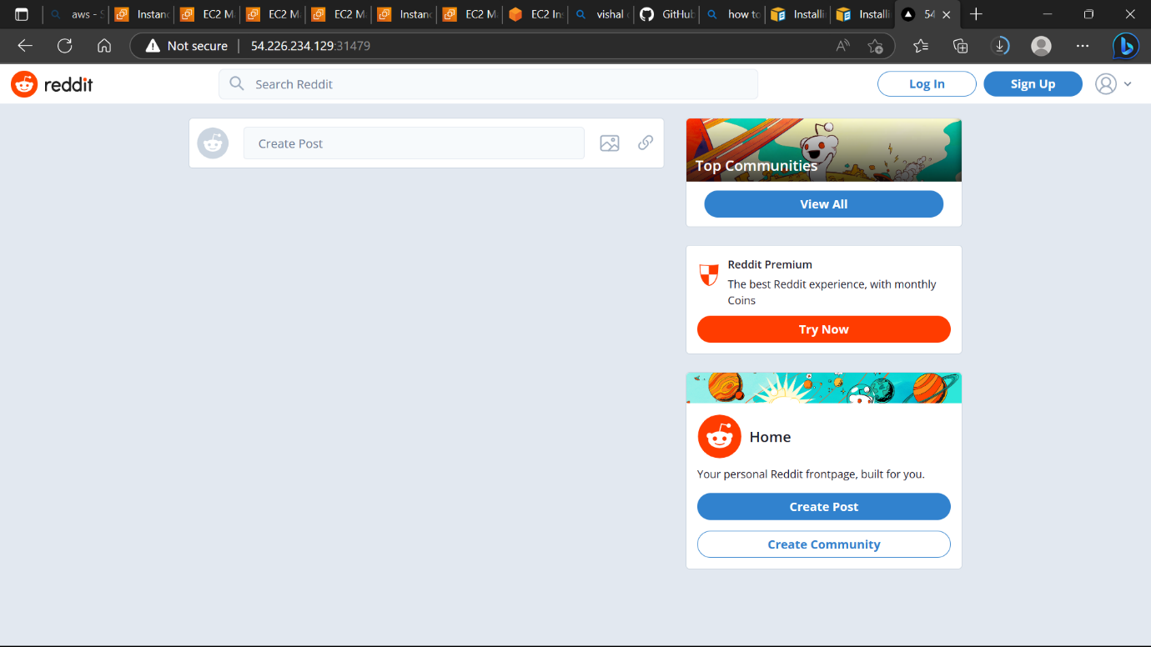

* **Do the same for the second public instance.**

 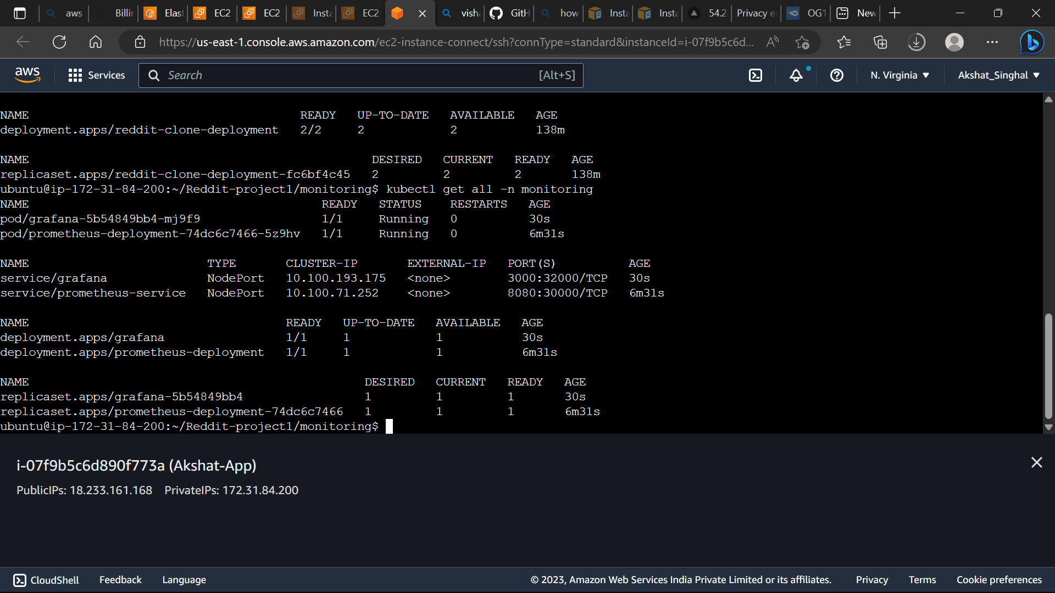

* **cd monitoring**
* **kubectl apply -f kubernetes-prometheus/.**
* **kubectl apply -f kubernetes-grafana/.**
* **Kubectl get all**
* **kubectl get all -n monitoring**
* **Add rules in a public ec2 instance**

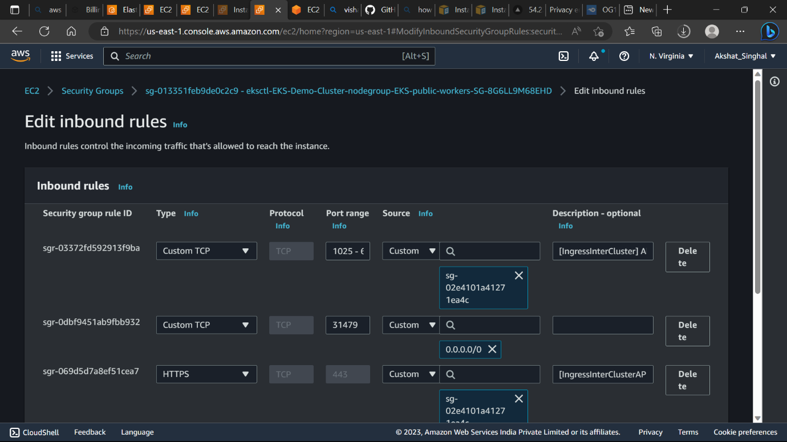

**30000 -> prometheius**

**32000-> Grafana**

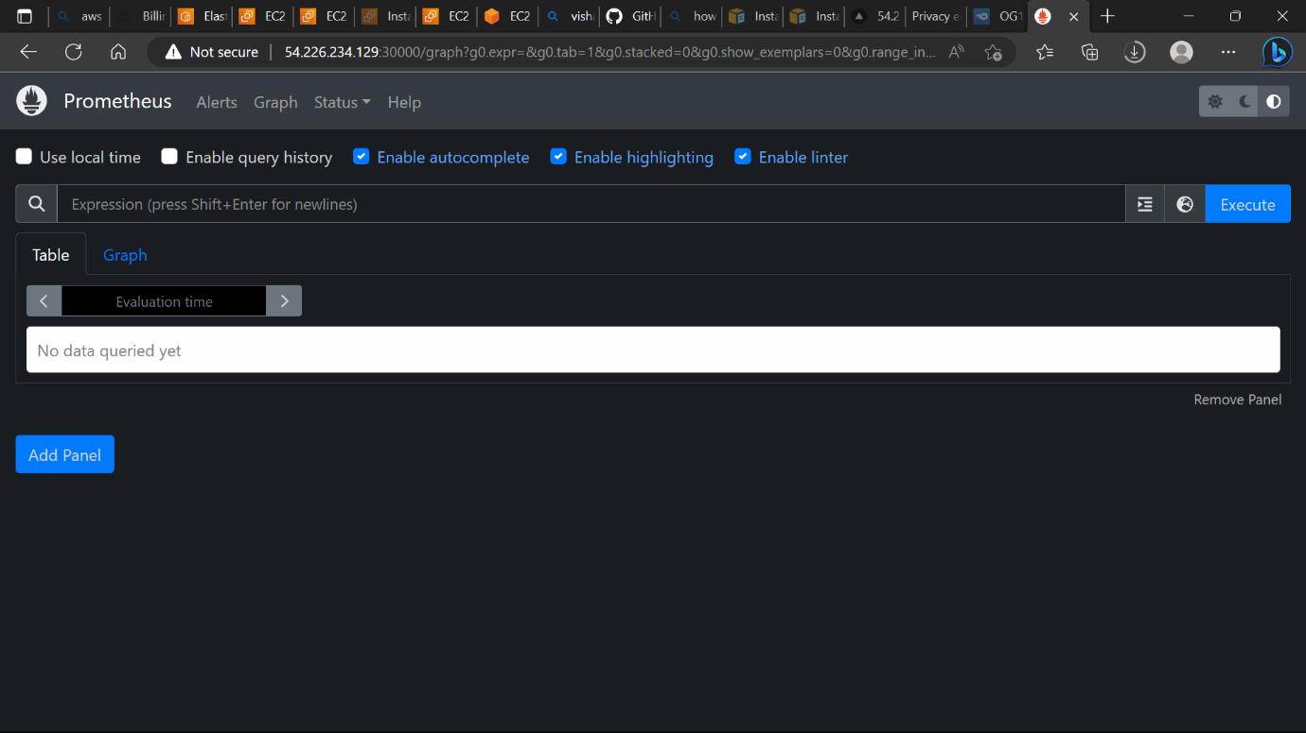

* **Set admin as username and password of Grafana.**

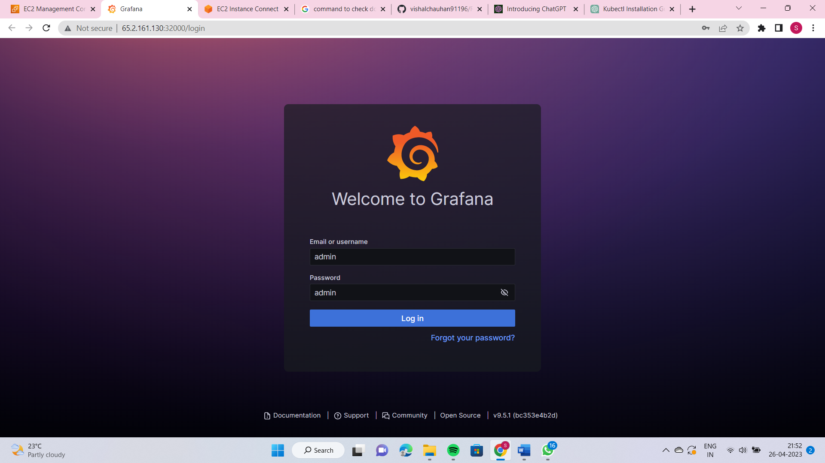

* **Click on Import Dashboard**

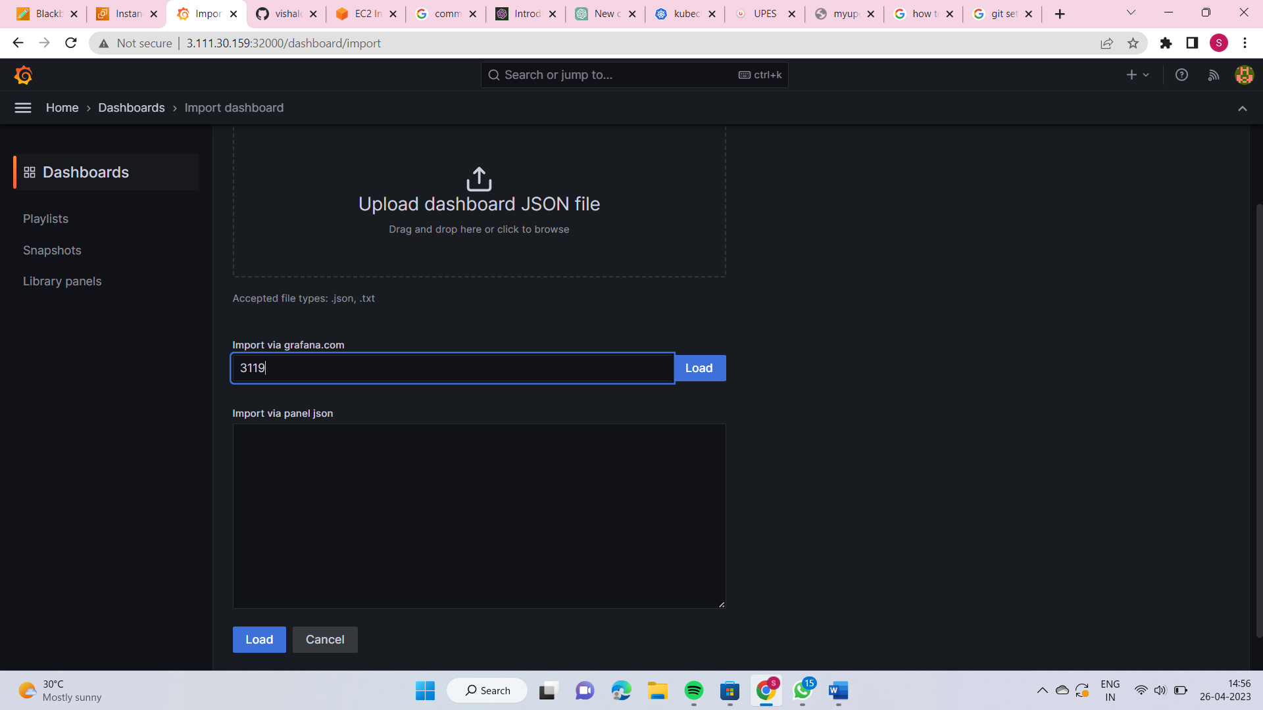

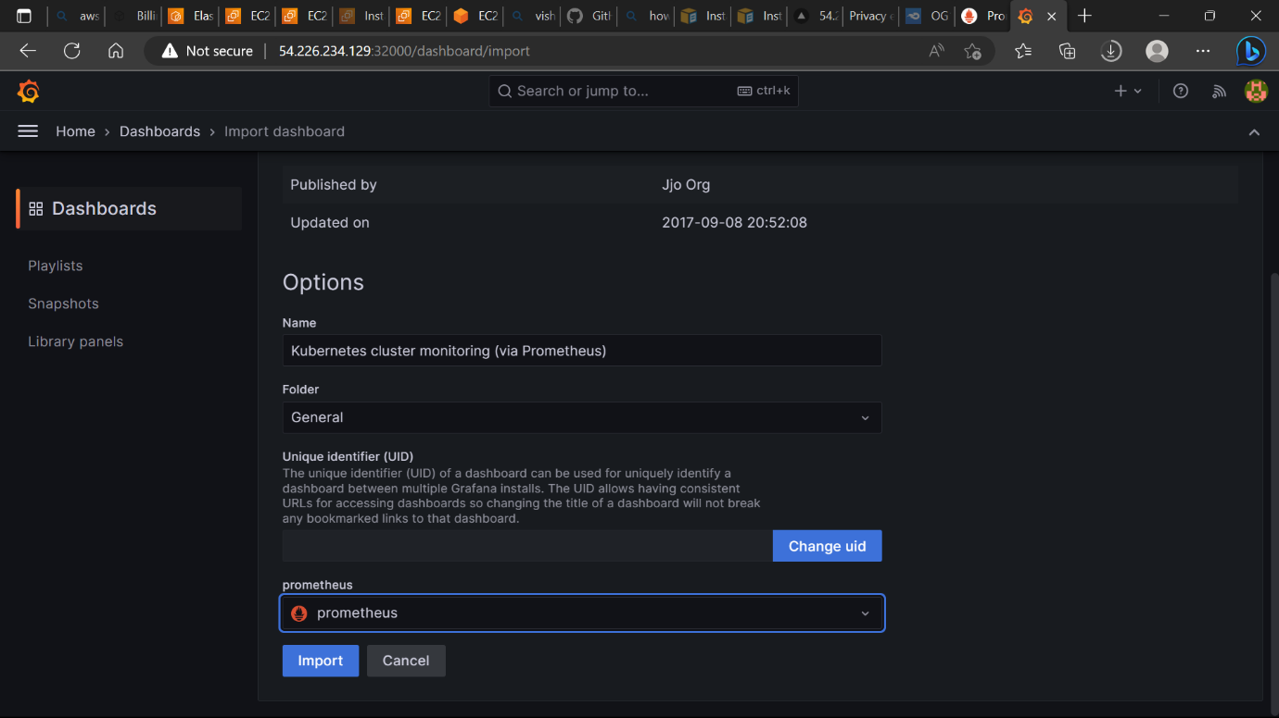

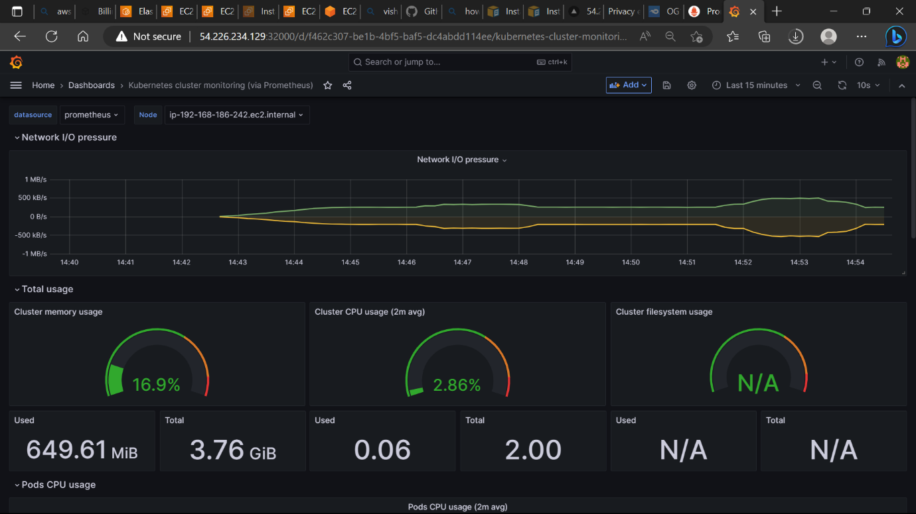

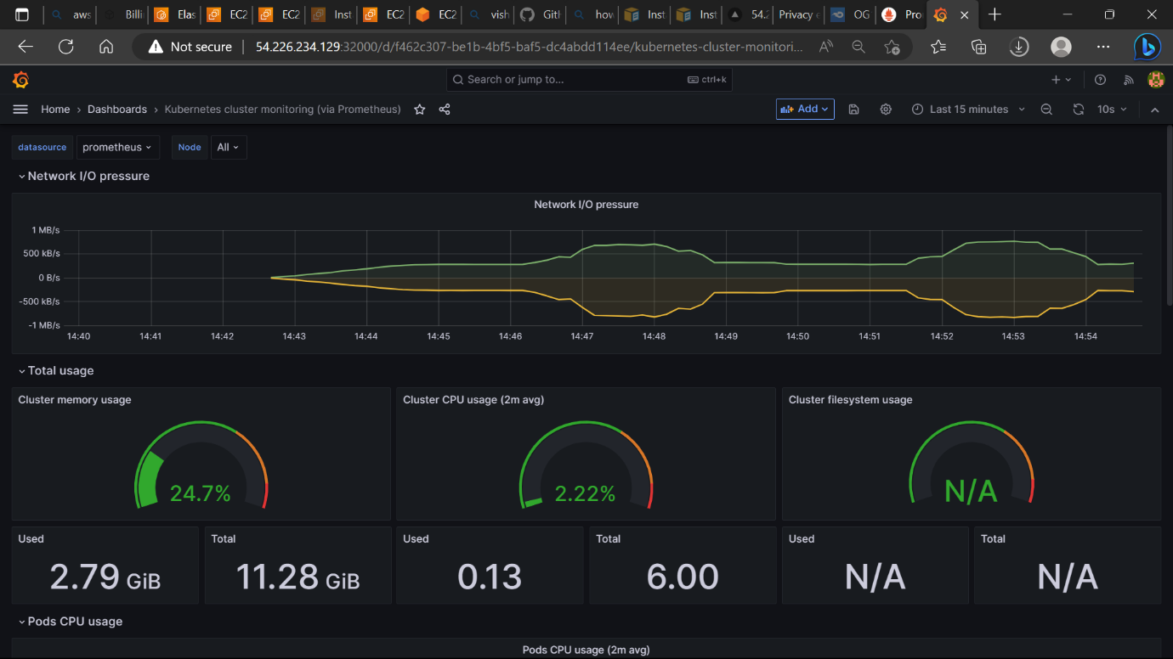

Now we have finally Deployed the application on eks cluster using ecr and monitoring of it using Prometheus and Grafana.

For deleting the cluster we use the following command: -

